

**Concordia Institute for Information System Engineering (CIISE) Concordia University.**

**INSE 6210: Total Quality Methodologies in Engineering**

**PROJECT REPORT**

**Reducing Waste and Improving Productivity of a Manufacturing Organization using DMAIC principles**

**April 17, 2019**

**Submitted to:**

**Professor Dr. Nizar Bouguila**

**Submitted by:**

|  |  |
| --- | --- |
| **Student Name** | **Student ID** |
| Antony Wilson | 40057563 |
| Natasha Basutkar | 40081017 |
| Shreyas Dhuru | 40048712 |
| Sushma Reddy Gurram | 40086757 |

Contents

I. EXECUTIVE SUMMARY 4

1. INTRODUCTION 5

2. DEFINE 5

2.1. Project Charter 5

2.2. Gantt Chart 6

2.3. SIPOC 7

2.4. Value Stream Map 7

2.5. Critical to Quality Parameters 8

2.6. Pareto Chart 9

3. MEASURE 9

3.1. DPMO 9

3.2. Process Capability 10

3.3. QFD (Quality Function Deployment) 11

4. ANALYZE 12

4.1. Cause and Effect Diagram 12

a. Fishbone for Reworks 13

b. Fishbone for Low Customer Satisfaction 13

4.2. Root and Cause Analysis 14

4.3. Why Techniques 14

a. Rework of Product 14

b. Rework of Product 14

c. Low Customer Satisfaction 15

5. IMPROVE 15

5.1. Brain Storming 15

5.2. Improvements Suggested through Kaizen Approach 16

5.3. Improvements suggested through Poka Yoke 18

5.4. Improved DPMO 19

5.5. Improved Process Capability 20

5.6. Profit Analysis 20

6. CONTROL 20

6.1. U- Chart 21

6.2. U-Chart Before DMAIC 21

6.3. U-Chart After DMAIC 21

7. CONCLUSION 22

*II.* REFERENCES 23

III. WORKLOG 23

# EXECUTIVE SUMMARY

Company ABC believes in providing the best customer service to their clients and had always had customer satisfaction as its top priority. ABC closely monitors customer feedback on daily basis and investigates every occurrence using post-fall huddles and organization wide monthly meetings. In the recent year, ABC observed that their customer satisfaction index rate decreased by 20 % from 80 % to 60 % in the year 2018. This prompted company to strengthen its quality control practices.

To address this problem and strengthen the quality control process, ABC hired an external quality process improvement team. This team was supported by various heads from various verticals from ordering to delivery.

The job of the external quality team is to study the legacy process and provide recommendations to improve the process. Team worked in co-ordination with the heads from the various verticals of ABC, identified procedures and policies in place to prevent falls. The team found three primary problems. in the define phase we had consolidated on various feedback surveys from the customer to corner down on the main points of focus from customer view and understood the major CTQs to be on "Timeframe - Late Delivery" and "Customer Satisfaction - Low Index". Later the analyze phase helped us to identify the root cause impacting the major CTQ was due to

1. Poor quality of the finished product
2. Wastage of raw materials
3. Delayed Customer Deliver

This project is to help ABC to overcome the above problems and thereby improve the customer satisfaction. This is done using the DMAIC (design, measure, analyze, improve and control) process and data analysis. We have also used several other techniques from DMAIC process in different phases.

# INTRODUCTION

With over 30 years’ experience and fueled by innovation and creativity, Company ABC offers the quality and services required to manage end-to-end custom programs. With domestic and international capabilities, 1 000 000 sq. ft. of manufacturing space, and best-in-class automated machinery, Company ABC has always aimed at providing the best customer service to their clients. Their client-centric approach has enabled them partner with their clients all while offering the support needed to create custom hybrid programs to satisfy all the necessary project requirements needed to make each project a success every step of the way.

Every manufacturing organization has quality issues and they are often ignored. However, for every problem there is a solution as well. There are various problems for example:

* Low productivity
* Increasing rejection
* Not meeting the delivery schedules
* Improper inventory control
* Increasing wastage
* Unmanaged shop floor
* Improper planning, etc.

Introduction of quality methodologies to organizations can help tackle these issues and resolve them. Implementing quality in any organization has emerged as a strategic competitive tool for the organization’s success. Adopting quality philosophies has become essential in establishing goals of winning and doing well in the competitive world. Therefore, implementing quality management in the manufacturing industry is a key factor to improving products, customer/supplier relationships and the organization’s goals.

# DEFINE



# Project Charter

|  |
| --- |
| **PROJECT CHARTER** |
| **Title:** Reducing Waste & Improving Productivity of a Manufacturing Organization Using DMAIC Principles |
| **Sponsor:** ABC Company |
| **Start Date:** Jan. 08, 2019 |
| **Expected End Date:** Mar. 19, 2019 |
| **Area of Development:** Process Improvement |
| **Business Case:**   1. Reduce the reworks 2. Improve the Delivery Process 3. Improve Customer Satisfaction |
| **Key Deliverables:**   |  |  | | --- | --- | | **Deliverable** | **Date** | | Project Proposal | Feb. 05, 2019 | | Project Final Report | Apr. 02, 2019 | |
| **Funding:** Quality Control Department |
| **Milestones:**   |  |  | | --- | --- | | **Milestone** | **Timeline** | | Define the metrics for the identified processes. | Jan. 2019 | | Collect and analyze the gathered data. | Jan. 2019 | | Propose a method to reduce the impact of established causes. | Feb. 2019 | | Determine a process to monitor the improvement and control it. | Mar. 2019 | | Present our project to our colleagues and professor. | Apr. 2019 | |
| **In Scope:** Improve the quality from stamping phase to the assembling phase |
| **Out of Scope:** Introducing new product or automation to the system |
| **Assumptions, Risks and Constraints:**   1. Process is defined based on the assumption that data available is right 2. Data is limited 3. Communication with the company is limited |
| **Approved By:** ABC Company |

# Gantt Chart

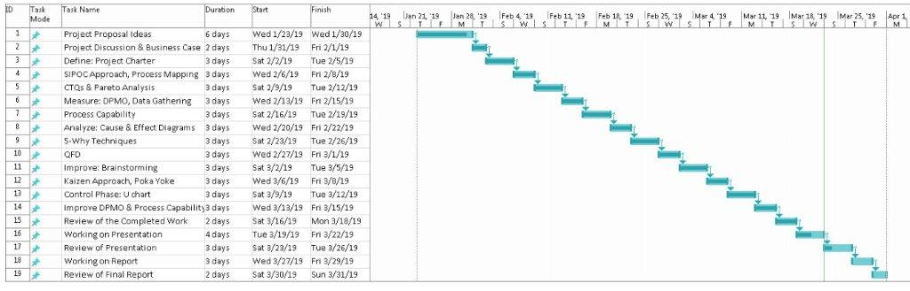

Figure 1: Gantt Chart

# SIPOC

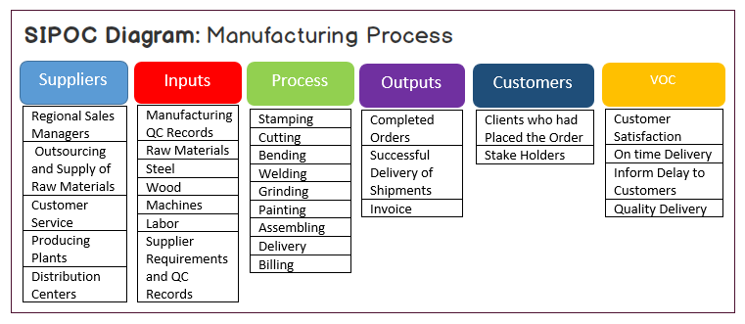

Figure 2: SIPOC Diagram

# Value Stream Map

Value stream mapping is a lean management tool that helps visualize the steps needed to take from the product creation to delivering it to the end-customer. This aspect allows one to measure the impact of value-added and non-value-added activities on the total lead-time of the process. This information provides a factual basis for identifying improvements in the improve phase of DMAIC process.

From the figure displayed below shows us the current state of the process on the shop floor at ABC Company. On observing, the value stream map we can say that at present they are following the push system where each process depends on the previous process’s output so that the production can carry on and the product be manufactured to its completion.

This leads to drawbacks such as:

* High work in process inventories
* Increase in wait time
* Increase in wait time also leads to an increase in total lead-time of the process.
* Hence, it takes a longer time for a product be delivered to the customer.

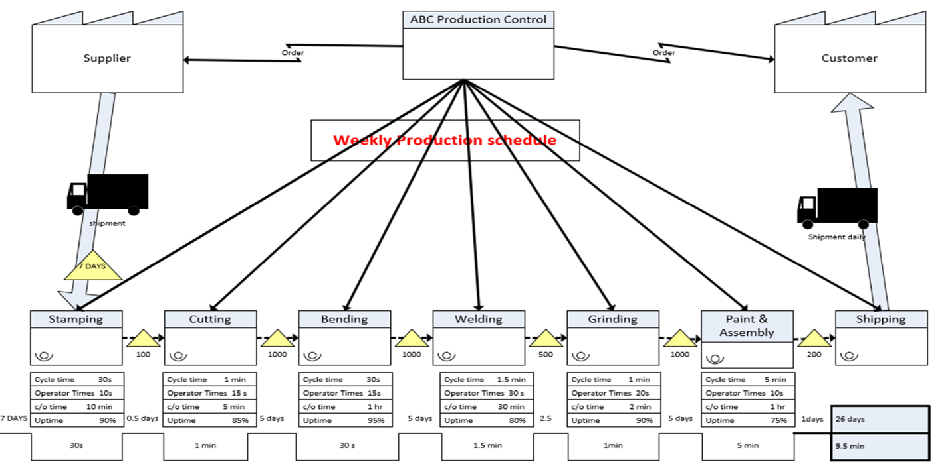

Figure 3: Value Stream Map

# Critical to Quality Parameters

Based on the feedback and reporting frequency from the customers, few problems are noticed and categorized. On analyzing the customer’s opinion on their order experience the below table-1 was generated. Further on generating the Pareto chart from table-1, gave us the necessary insight to narrow down the problem and understand on the main CTQ that required attention.

|  |  |  |  |
| --- | --- | --- | --- |
| **Customer Feedback** | **Reporting Frequency** | **Percentage %** | **Cumulative %** |
| Quality of the manufactured item | 126 | 24% | 24% |
| Overall customer satisfaction | 108 | 20% | 44% |
| Missing items | 71 | 13% | 58% |
| Delayed order delivery | 65 | 12% | 70% |
| Missing quality of the deliverable | 59 | 11% | 81% |
| Lack of experienced working team | 56 | 11% | 92% |
| Vendor/Supplier issues | 42 | 8% | 100% |

Table 1: Critical to Quality



# Pareto Chart

Going by the Pareto principle that 80% of the problem is because of the 20% causes with respect to it, the major CTQ’s of the project are identified and categorized below from the Pareto chart.

Figure 4: Pareto Chart

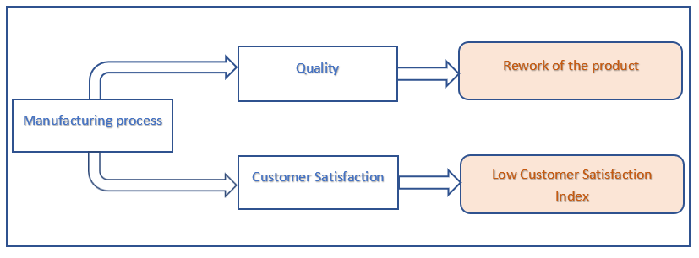

Figure 5: Major CTQ’s based on Pareto Chart

# MEASURE



# DPMO

The DPMO metric is a measure of capability for discrete (attribute) data. It is the calculation of number of defects per million opportunities. For a Six Sigma process the DPMO is 3.4.



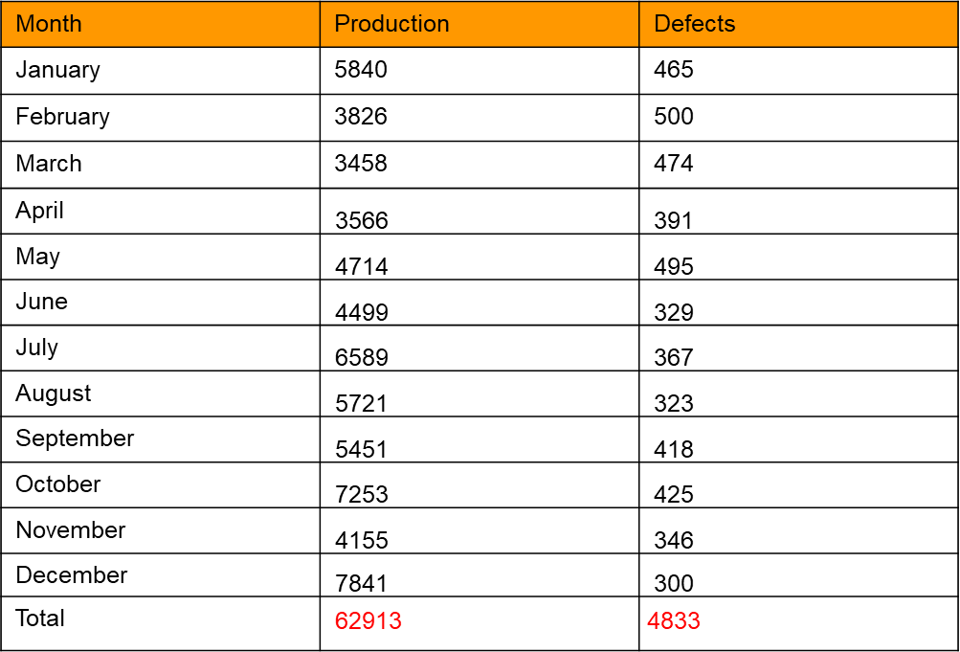The DPMO metric is very important because of it permits you to match differing kinds of product. Developing a purposeful DPMO metric across multiple product lines, however, is time intense because of it's necessary to accurately verify the amount of how (or opportunities) a defect will occur per unit. This could be a colossal task, notably once coping with extremely complicated product and subassemblies, or perhaps work.

Table 2: DPMO

The DPMO of the current state was calculated by using the monthly production and defect data shown above. The DPMO was calculated to be = (62915*1000000/4833) = 78620. The corresponding Sigma level was 2.9.



# Process Capability

The process capability is a statistical indicator of how well it is functioning, or, in other words, how successful it is at running within its specified limits. In the absence of any special or assignable causes of variation, a process will still have some inherent variability. Process capability is a statistical measure of this inherent variability.

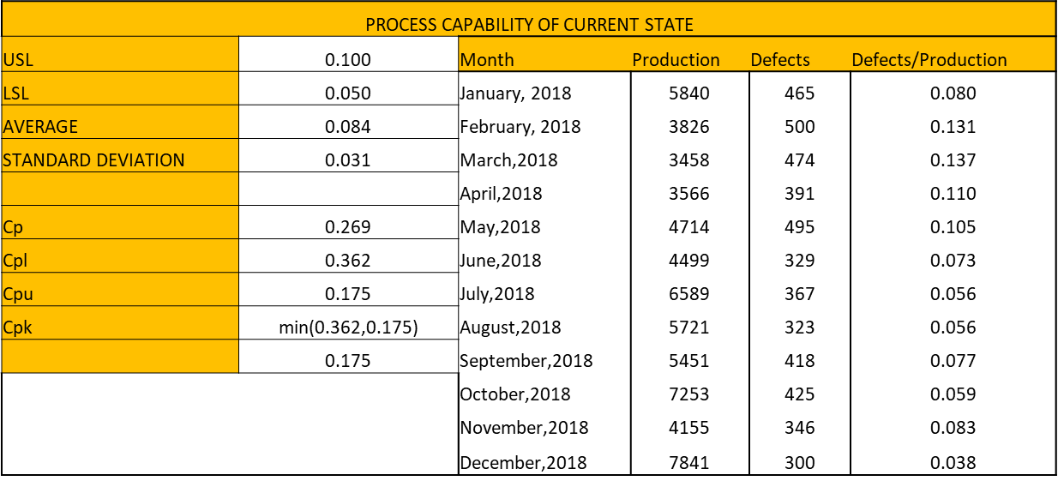

Table 3: Process Capability - Current state

In the above table, we found out are process capability indexes and the Cpk value was 0.175 suggesting the process is not capable and needs improvement.

# QFD (Quality Function Deployment)

Quality Function Deployment (QFD) is a structured approach to defining customer needs or requirements and translating them into specific plans to produce products to meet those needs. The “voice of the customer” is the term to describe these stated and unstated customer needs or requirements. This understanding of the customer needs is then summarized in a product planning matrix or “house of quality”. These matrices are used to translate higher level “what’s” or needs into lower level “how’s” – product requirements or technical characteristics to satisfy these needs.

Below we have captured our customer and technical requirements and provided the relationship between them to help us understand and prioritize the needs of the customers.

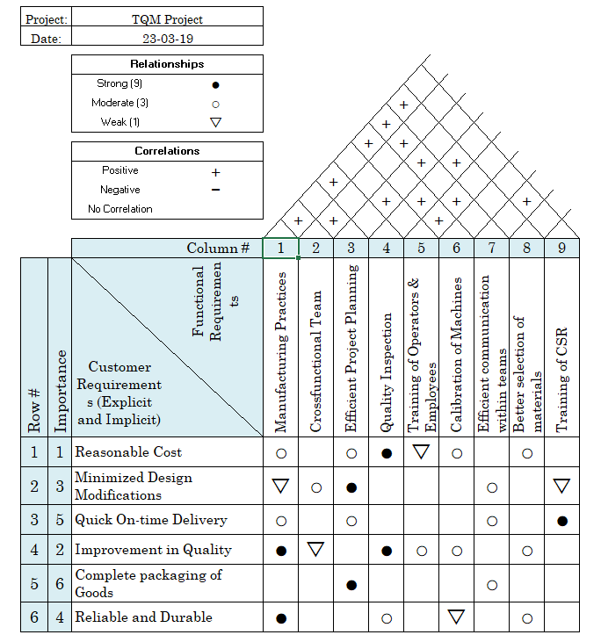

Figure 6 :House of Quality

# ANALYZE



# Cause and Effect Diagram

Cause and Effect Diagram also known as Ishikawa or Fishbone diagram is a tool that is used to identify, sort and display the possible causes of a specific problem or quality characteristic. It gives us the relationship between a given outcome and the all the factors that influence the outcome. It helps to determine the root causes of a problem using a structured approach.

We have represented two fishbone diagrams depicting two of the major causes, which lead to a high DPMO. The two major drawbacks identified by us using the Pareto chart are low customer satisfaction and high rate of rework. By understanding the causes and effects of these problems, we intend to work on resolving these issues and reduce the DPMO.

The two fishbone diagrams are as represented below.

### Fishbone for Reworks

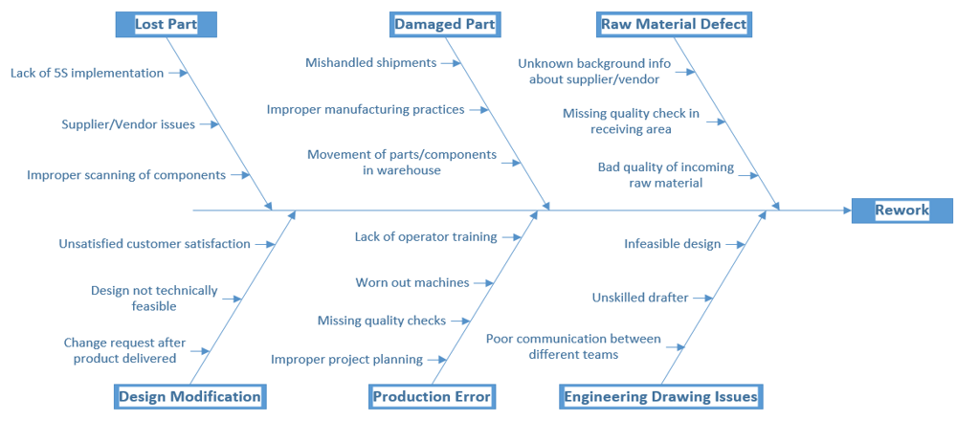

Figure 7: Fishbone Reworks

### Fishbone for Low Customer Satisfaction

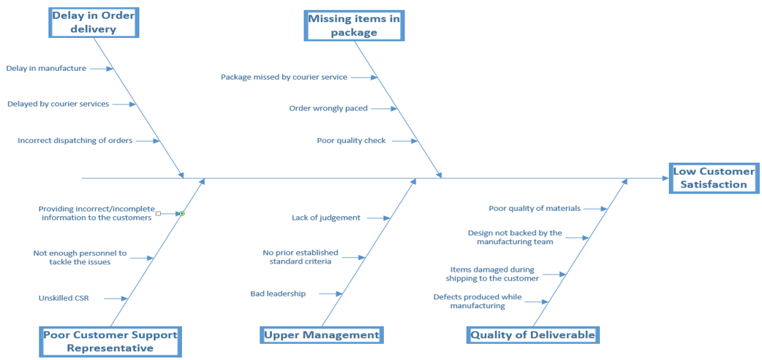

Figure 8: Fish Bone - Low Customer Satisfaction



# Root and Cause Analysis

This analysis is done in-order to list out the causes pertaining to Rework of the products during manufacturing and low customer satisfaction. We used 5-Whys technique to sort out what all steps involved in the procedure of production and the item reaching to the customer and analyzed the root-causes.

# Why Techniques

### Rework of Product (1)

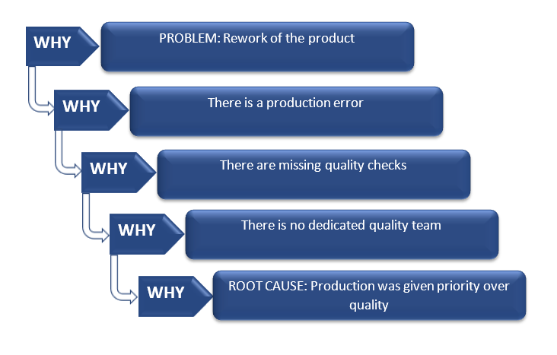

Figure 9: Rework of Product

### Rework of Product (2)

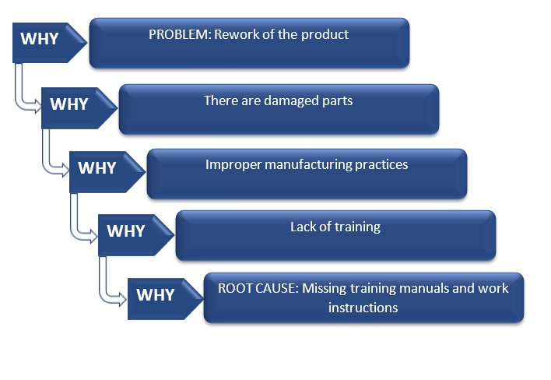

Figure 10: Rework of Product

### Low Customer Satisfaction

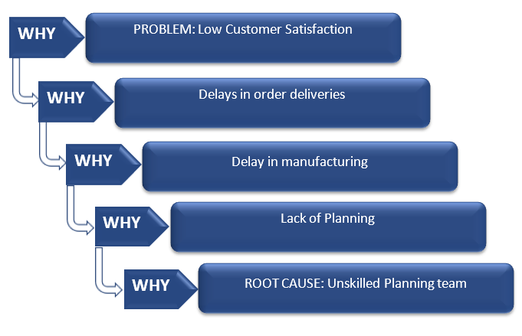

Figure 11: Low Customer satisfaction

# IMPROVE



# Brain Storming

Based on the output from the Pareto chart, we have learnt that the **Overall customer satisfaction** and **Rework** are major causes and hence can be selected as possible candidates for Improvement.

There are several reasons for Rework such as **Lost parts** in the warehouse, **Missing items** from Supplier/Vendors, **Lack of organized spaces** in the warehouse which calls for a need in the change of processes such as introducing 5S Implementation to keep the clutter away. Along with this, we also need to introduce a level of inspection for the missing items from the Vendor/Supplies issues as this will help to reduce losses considerably for the ABC Company.

The other major reason for Rework is the **Lack of coordination** between various teams such as Design, Engineering and Production. This is leading to issues such as the Designs produced are not technically feasible and extra efforts are required for rework to amend the design document leading to delays in the project.

Additionally, one of the significant issues reported is **Improper project planning** by the teams without prioritizing the projects as per the urgency. This is leading to inefficient usage of Inventory warehouses and delays in projects thereby affecting the Customers.

There is also a strong need to improve the **existing manufacturing practices** such as giving proper training to employees, proper documentation of the design specifications and providing standard work instructions, conducting training sessions for Knowledge transfer from the Engineering team to the operators, etc.

Similarly, there are several causes affecting the **Customer Satisfaction** such as delays in order delivery, missing items reported by users, Unskilled customer support to answer queries and solve the customer’s problems and Lack of ownership in the management teams.

After brainstorming the above mentioned issues, we have identified few points that require urgent attention and have provided the most optimal solutions considering the below factors:

* The solutions must be easy to implement and adaptable in day to day activities.
* The solutions must be cost effective.
* The solutions will not introduce any new overheads to the organization in terms of cost or resources.

# Improvements Suggested through Kaizen Approach

|  |  |
| --- | --- |
| **Problems** | **Measure Taken** |
| 1.Production Errors/Defect | * Introduce quality checks at every stage of the process. |
| 2.Lack of proper manufacturing practices | * Provide proper training to operators and other employees working on the floor. * Checking the progress of newly hired operators on a regular basis. * Introduce trainings by experienced staff, this will help the staff to solve commonly occurring problems. * Assign a Buddy Manager to a group of freshers to help them understand the culture of the organization, help them with the regular day to day activities in their initial days. |
| 3.Lack of coordination between Design, Engineering and Production teams. | * Conduct regular meetings to understand and track the progress. These meetings can also be used to overcome bottlenecks and providing suitable solutions without affecting the project deadlines. * Engaging teams in the Group-related activities such as day-outings, fun activities playing games, sports, etc. This will help the teams to break the ice and get along with the teams together. * A manager is required to effectively manage these teams, resolve conflicts among teams and allow smooth functioning of the system. |
| 4. Delay in Order delivery | * Improve project planning by prioritizing the projects according to the delivery deadlines. This will also help to efficiently manage inventory storage. * Achieve preventive maintenance for machines to avoid delays when the machines go down affecting deliverables to a great extent. This can be done by regular maintenance of machines. * Operators should also be trained to resolve minor issues by using troubleshooting tips. |

Table 4: Kaizen Approach

# Improvements suggested through Poka Yoke

Poka Yoke is a kind of mistake proofing method to avoid forgetfulness and common errors at early stages of development. It is a very powerful tool that can be applied to improve the products and processes in the manufacturing industry. Considering the problems that we are facing in the ABC Company, we realized Poka Yoke can help us resolve some issues and help us deliver better quality products.

|  |  |
| --- | --- |
| **Problems** | **Measures Taken** |
| Production Errors | * Provide checklist such as standard work instruction for all involved processes. |
| Avoid accidents on the floor and resolve safety issues | * Machines should go into idle state if the operator is away from the machine. * Machines should be insulated and shock-proof. * Machine should have warning signs to alert operators about safety issues. * Blinking lights and alarms can be installed to signal operators for emergency situations. |
| Insufficient technical knowledge of the Engineering team | * Retrain the employees. * Re-certify the skills of the employees. * Document the processes by embedding the details in the process. By putting things on the paper, it will help the mind to think of the broad view of the challenges and provide better solutions. |

Table 5: Poka Yoke Approach

# Improved DPMO

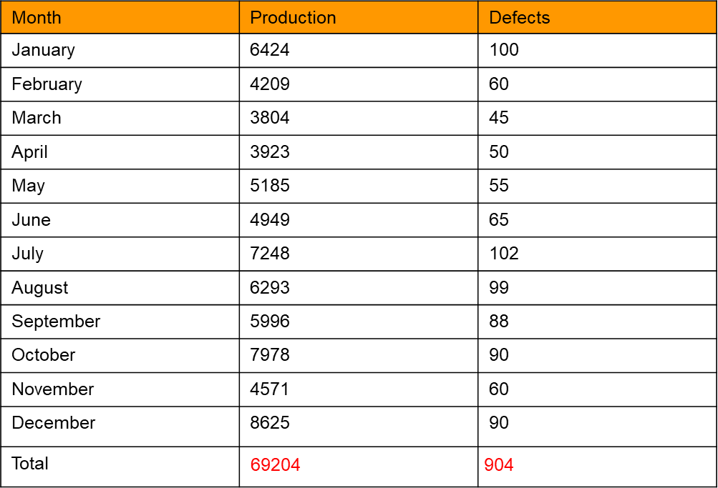

Table 6: Improved DPMO

The future DPMO was calculated from the above data sheet with production and defects information. The defects reduced significantly, and the DPMO reduced to 13063 with an improvement in process sigma level to 3.7.

# Improved Process Capability

Table 7: Improved Process Capability

After performing the six sigma improvements the future Process Capability was calculated as shown above. The Cpk value is greater than one and is 1.126 suggesting that the process is capable.

# Profit Analysis

The total cost incurred by the ABC Organisation in the last year was close to 515K. The main reasons for this rework cost were due to missing items reported by the customers, missing items reported in the warehouse, damaged parts, mishandled shipments, etc. If the Six Sigma quality control checks are implemented, we can see a huge improvement in the quality of the products. The number of defects that were reported in 2018 alone were 4833 which can be reduced to close to 904 by putting the quality control checks in place. However, the investment required to implement Six sigma is approximated to 800K and it will benefit the company with estimated savings of around 419K. The Return on Investment can be expected past 1.9 years. Hence, the figures are a clear indication that the implementing Six sigma will reduce the rework costs, improve profits and provide better customer satisfaction.

# CONTROL

The control chart is a graph used to study how a process changes over time. Data are plotted in time order. A control chart always has a central line for the average, an upper line for the upper control limit and a lower line for the lower control limit. These lines are determined from historical data. By comparing current data to these lines, you can draw conclusions about whether the process variation is consistent (in control) or is unpredictable (out of control, affected by special causes of variation).



# U- Chart

The U chart was identified to be implemented for the control charts as we are concentrating on defects and not defectives. The control charts are plotted using the mini tab from the obtained data.

# U-Chart Before DMAIC

The current control chart shown below shows UCL=0.0862, LCL=0.0674 and mean=0.0768. There are 8 outliers suggesting the process is out of control and needs further modification.

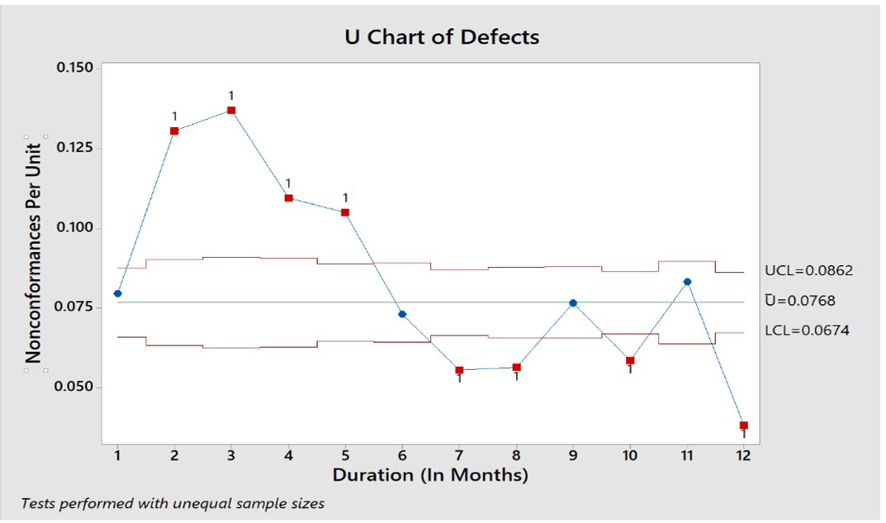

Figure 12: U-Chart before DMAIC

# U-Chart After DMAIC

The control chart shown below is after the six-sigma implementation and it can be seen that there are no outliers and the process is stable with UCL=0.01675, LCL=0.00937 and mean value=0.01306.

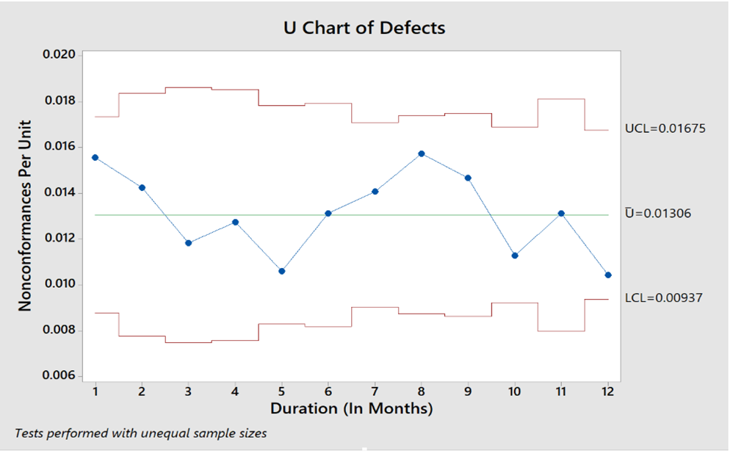

Figure 13: U-Chart after DMAIC

# CONCLUSION

The suggested process will improve the customer satisfaction, reduce the reworks growth of the organization, customer retention and customer referrals.

By applying DMAIC principles, the future state of our ABC organization is as follows:

* DPMO is reduced from **76820** to **13063**.
* Process sigma is increases from **2.9** to **3.7**
* Process is under control and stable. This is clearly visible in the control charts.
* Process is consistent and capable as we have a Cp value of **more than** **1**. This is clearly visible in the process capability calculations.
* By implementing six sigma an amount of **$ 419, 218** will be saved per year after the breakeven point (1.9 years).

# REFERENCES

|  |
| --- |
| 1. *S. K. Saxena, "ASQ Six SIgma Forum," [Online]. Available:* [*http://asq.org/sixsigma/process-capability.pdf*](http://asq.org/sixsigma/process-capability.pdf) *[Accessed 10 April 2019].* |
| 1. *T. Kubiak, "Quality progress," [Online]. Available:* [*http://asq.org/quality-progress/2009/08/34-per-million/perusing-process-performance-metrics.html*](http://asq.org/quality-progress/2009/08/34-per-million/perusing-process-performance-metrics.html)*. [Accessed 10 April 2019].* |
| 1. *"Quality Glossary Definition: Control Chart," in The Quality Toolbox, Second Edition, ASQ Quality Press, American Society for Quality.* 2. [*https://en.wikipedia.org/wiki/Six_Sigma*](https://en.wikipedia.org/wiki/Six_Sigma) 3. [*https://www.graphicproducts.com/articles/six-sigma-principles/*](https://www.graphicproducts.com/articles/six-sigma-principles/) 4. [*https://moodle.concordia.ca/moodle/course/view.php?id=113312*](https://moodle.concordia.ca/moodle/course/view.php?id=113312) 5. *An Introduction to Six Sigma & Process Improvement, by James R. Evans and William M. Lindsay, Second Edition.* |

1. *Class notes*

# WORKLOG

|  |  |  |  |  |
| --- | --- | --- | --- | --- |
| **Task Description** | Antony Wilson | Natasha Basutkar | Shreyas Dhuru | Sushma Reddy Gurram |
| Executive Summary | ✓ | ✓ | ✓ | ✓ |
| Introduction | ✓ | ✓ | ✓ | ✓ |
| Define |  | ✓ |  | ✓ |
| Measure | ✓ |  |  | ✓ |
| Analyze | ✓ | ✓ | ✓ | ✓ |
| Improve |  | ✓ | ✓ |  |
| Control | ✓ |  | ✓ |  |
| Conclusion | ✓ | ✓ | ✓ | ✓ |
| PPT and Report | ✓ | ✓ | ✓ | ✓ |

Table 8: Work Log